FTF FY 2023 Performance Scorecard USAID Rwanda

This Feed the Future (FTF) Performance Scorecard assesses the USAID Rwanda progress toward FY 2030 Performance Targets.

# Performance Overview



The FY 2023 **On track** value is determined by drawing a line from the baseline (FY 2022) to the FY 2030 Target. For FY 2023, Performance Targets are considered **On track** if they have reported at least 90% of that value.

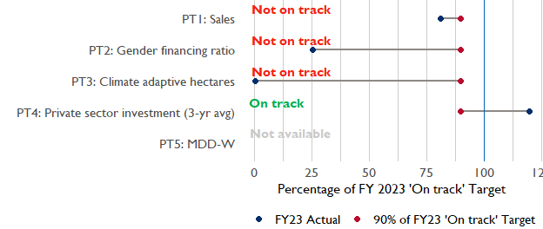

**Note:** *For Performance Target 2 (Gender financing ratio), the target is to increase financing to females for those OUs that are already achieving parity ($1).*

*For Performance Target 4 (PSI), all targets are relative to the last three years’ reporting. In future years, the interim targets may increase.*

*For Performance Target 5 (MDD-W), all FY23 actual values are also the baseline, and may have been collected in a prior year. See the detail page for more information.*

*See detailed* [*methodology document*](https://docs.google.com/document/d/13n-43ppFiGKauscQ7HaAiQDCM4DssGEgRdq2fMyTDn0/edit) *here. If you have questions, please email the FTF Data and Analytics team at* [refs.adl.da@usaid.gov](mailto:refs.adl.da@usaid.gov).

### Performance Target (PT) Details

This section shows PT scores for each applicable PT for USAID Rwanda.

## Performance Target 1: Value of annual sales of producers and firms receiving USG assistance



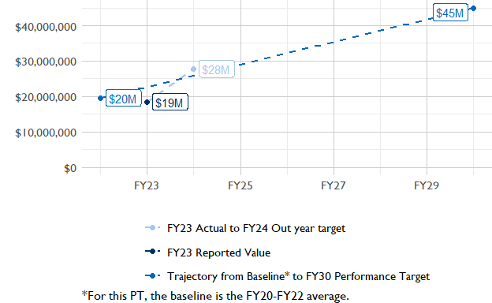

In FY 2023, USAID Rwanda had 5 activities that aligned the ‘Value of annual sales from producers and firms receiving USG assistance’ (EG.3.2-26), and 1 contributed to the sales total of $18,500,000.

###### Performance Target 2: Value of financing accessed by female FTF participants per $1 of financing accessed by male FTF participants



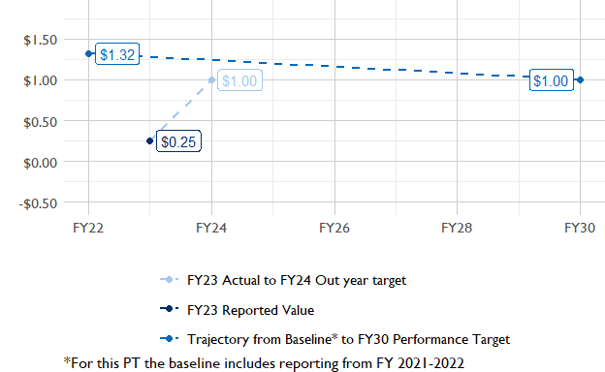

In FY 2023, USAID Rwanda had 3 IMs/Activities that reported all four sex disaggregates needed to contribute to PT2. The total value of financing among all activities, regardless of disaggregates, was $15,510,000 (EG.3.2-27 total), with $15,510,000 that was disaggregated by females and males, and an additional $27,630,000 to ‘mixed’ firms that have both males and females, and $9,220,000 that was not sex disaggregated.

###### Performance Target 3: Number of cultivated hectares under climate adaptation/climate risk management practices and technologies with USG assistance



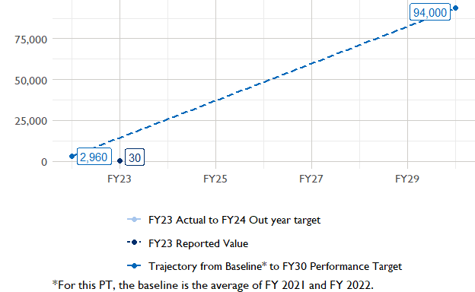

In FY 2023, Rwanda had 11 activities that aligned the indicator for hectares under improved management practices (EG.3.2-25). Of those activities, 1 reported on the ‘Climate adaptation/climate risk management’ disaggregate and contributed to the OU total for this PT.

###### Performance Target 4: Value of private sector investment leveraged by the USG to support food security and nutrition



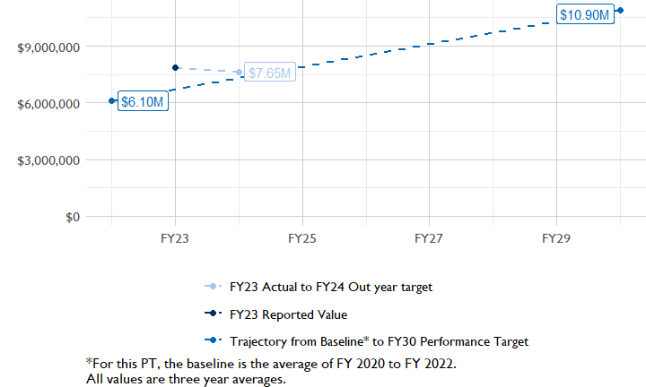

In FY 2023, Rwanda had 3 activities that aligned the private sector investment indicator (EG.3.1-15/-14), ‘Value of new private sector investment leveraged by the USG to support food security and nutrition [IM-level]’, and 3 contributed to the OU total in FY 2023.

###### Performance Target 5: Percent of women consuming a diet of minimum diversity (MDD-W)



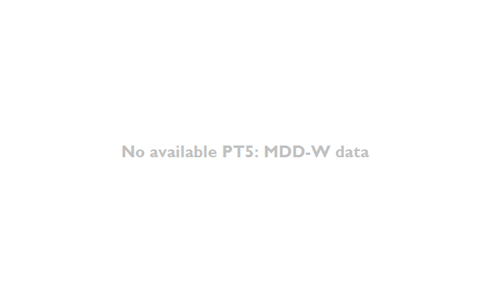

PT5 is not available for USAID Rwanda.

### National Context

National level data was collected from the [World Bank’s Open Data portal](https://data.worldbank.org/) that measures key indicators at the national level.

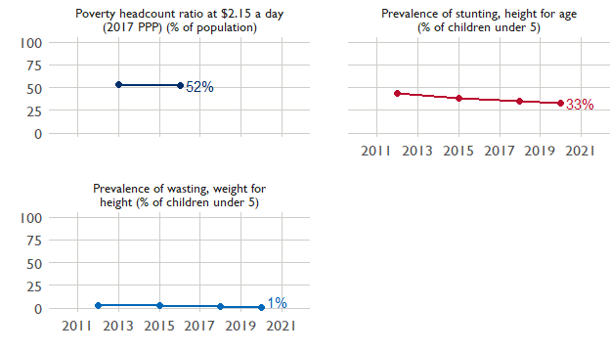

## Agricultural Transformation Index Score

The IFPRI Agricultural Transformation Index (ATI) Score is a high level indicator of the status of agricultural market systems in each country.

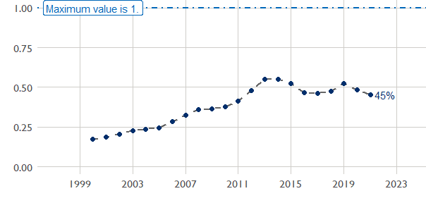

## Budget Trend

At the Operating Unit level, the Performance Targets are based in part on the FY 2024 budget request. The budget chart below includes EG.3 money only.

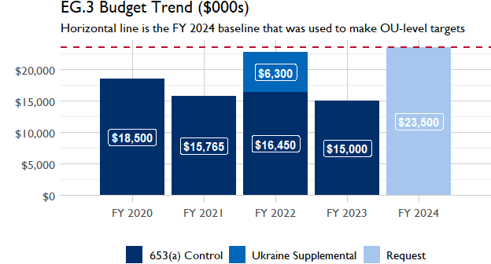

## Active Portfolio

The following activities are considered “active” based on their reporting in FY 2023 and expected FY 2024 reporting. The Analytics, Data and Learning Division defines an “active” activity as one that reported targets, actuals, or deviation narratives for the current year (FY 2023), or the next out year targets (i.e. FY 2024).

## Top Activities (Award Disbursements and Results)

This section highlights the 5 activities (out of the total 11 in the USAID Rwanda (RWANDA) portfolio) that have the highest level of FY 2023 annual disbursements and highest reported values for the relevant indicators. The first table below shows activities with the highest total transaction amounts. The columns to the right indicate if these activities are reporting on relevant PT indicators.

| Award Number | Activity Code | Activity Name | FY23 Disbursements | PT1 | PT2 | PT3 | PT4 |
| --- | --- | --- | --- | --- | --- | --- | --- |

The next table (below) shows the activities that reported the highest values for the relevant PT indicators. The total disbursements are included, if available.

| Award Number | Activity Code | Activity Name | Total Disbursements | Sales | Hectares | PSI |
| --- | --- | --- | --- | --- | --- | --- |
| 72069619C00001 | 2423 | Orora Wihaze | NA | $18,500,143 | NA | $2,558,977 |
| AID-OAA-A-17-00029 | 1183 | Tera Imbuto Nziza | NA | NA | 34 | NA |
| 72069618C00001 | 1190 | Nguriza Nshore | NA | NA | NA | $7,853,206 |
| 72062320D00013 | 4603 | Kungahara Wagura Amasoko | NA | NA | NA | $2,332,372 |
| AID-696-A-17-00006 | 1184 | Tworore Inkoko Twunguke | NA | NA | NA | NA |
| 72069622C00001 | 1182 | 107582: Employment and Entrepreneurship Activity - Hanga Akazi | NA | NA | NA | NA |
| !! Not reported !! | 6220 | ACCELERATED INNOVATION DELIVERY INITIATIVE (AID-I) Great Lakes Rapid Delivery Hub | NA | NA | NA | NA |

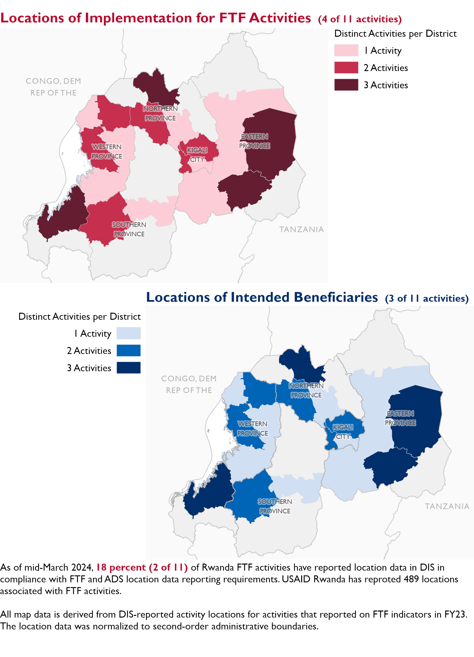

### Appendix 1: Response to “Not on track” Performance Targets

This section provides space for USAID Rwanda to provide an explanation of why the following PTs are not on track and how you could adjust to be on track in the coming year(s). To help in your response(s), the relevant section of the FTF/GFS Key Issue Narrative (KIN) is provided, as it *may be* useful in drafting a responses. Note that the KIN is addressing the sum of the out year targets (FY 2023) set by the USAID Rwanda activities that are reporting on each PT. The FY 2023 out year targets were set prior to the establishment of the FY 2030 Performance Targets, so the below explanations from the KIN may not apply to the Performance Target deviation.

* In Section 4 of the FTF KIN, your OU discusses FY24 and FY25 targets, while these Scorecards are addressing progress against a trajectory from historical reporting to your OU’s FY30 target. Also, the FY 2023 out year targets were set prior to the establishment of the FY 2030 Performance Targets. Therefore, the below explanations from the KIN may not apply to these FY30 Performance Target deviations.
* These responses will be used to compile a Congressional report, the GFSS Implementation Report, to discuss progress against the FTF FY 2030 Performance Targets, as mandated by the GAO.
* Only PTs that are ‘Not on Track’ require review and explanation from the OU.

Include in the response:

1. An explanation of why this target is not on track. Explanations may include that the OU/Mission was not aware of the target prior to planning activities.
2. Planned actions for ‘not on track’ targets. Planned actions may include the launch of new activities, building awareness, holding portfolio reviews, or other suggestions.

## Performance Target 1: Sales [Not on Track]

*Excerpt from FY23 KIN Section 4 to consider:*main driver for higher than expected results in FY 2023 was due to the Orora Wihaze activity’s expansion of interventions assisting firms in the Animal source food (ASF) sector. Orora Wihaze is the main contributor to high achievements on the value of annual sales receiving USG assistance as a result of gains generated from its market system approach and therefore meaningful engagement with local actors. Results for Kungahara Wagura Amasoko will not be available before the end of the calendar year which is the host country fiscal year and Hinga Wunguke was awarded in August 2023 with no target set for FY 2023. In FY 2024, Kungahara Wagura Amasoko, Hinga Wunguke and Entrepreneurship & Employment Activity will report on this indicator.

## Performance Target 2: Gender financing ratio [Not on Track]

*Excerpt from FY23 KIN Section 4 to consider:* are two facts for why there is FY 23 actual are much lower than the set targets. The first is that the actual results, mainly coming from Orora Wihaze, reflect the actual disparity for females in accessing finance compare to males when they all operate from an informal business perspective. Secondly, Kungahara Wagura Amasoko which supports financial institutional to increase their lending in agriculture is working with partner banks to provide disagregated data per sex. And we believe, we will be able to get actual targets for FY2024 in the coming weeks and therefore results as well. We believe the future projections will be a little bit positive as the gaps between number of females owned exports SMEs and the number of males owned SMEs is a little smaller. We will also follow up with new activity such as Hinga Wunguke to capture sex disagregated (by sex) results and therefore related targets.

#### Enter USAID Rwanda (RWANDA) response below:

## Performance Target 3: Hectares under climate adaptive and risk management practices [Not on Track]

*Excerpt from FY23 KIN Section 4 to consider:* FY 2023, the number of hectares under improved management practices or technologies with USG assistance decreased significantly compared to last year (from 35,968 to 1,131.86) because the main contributors Hinga Weze closed and Tera Imbuto Nziza was winding down, while the new Hinga Wunguke Activity is just starting. In FY 2024, Hinga Wunguke will help to climb the curve toward reaching the same level in FY 2025.

#### Enter USAID Rwanda (RWANDA) response below: